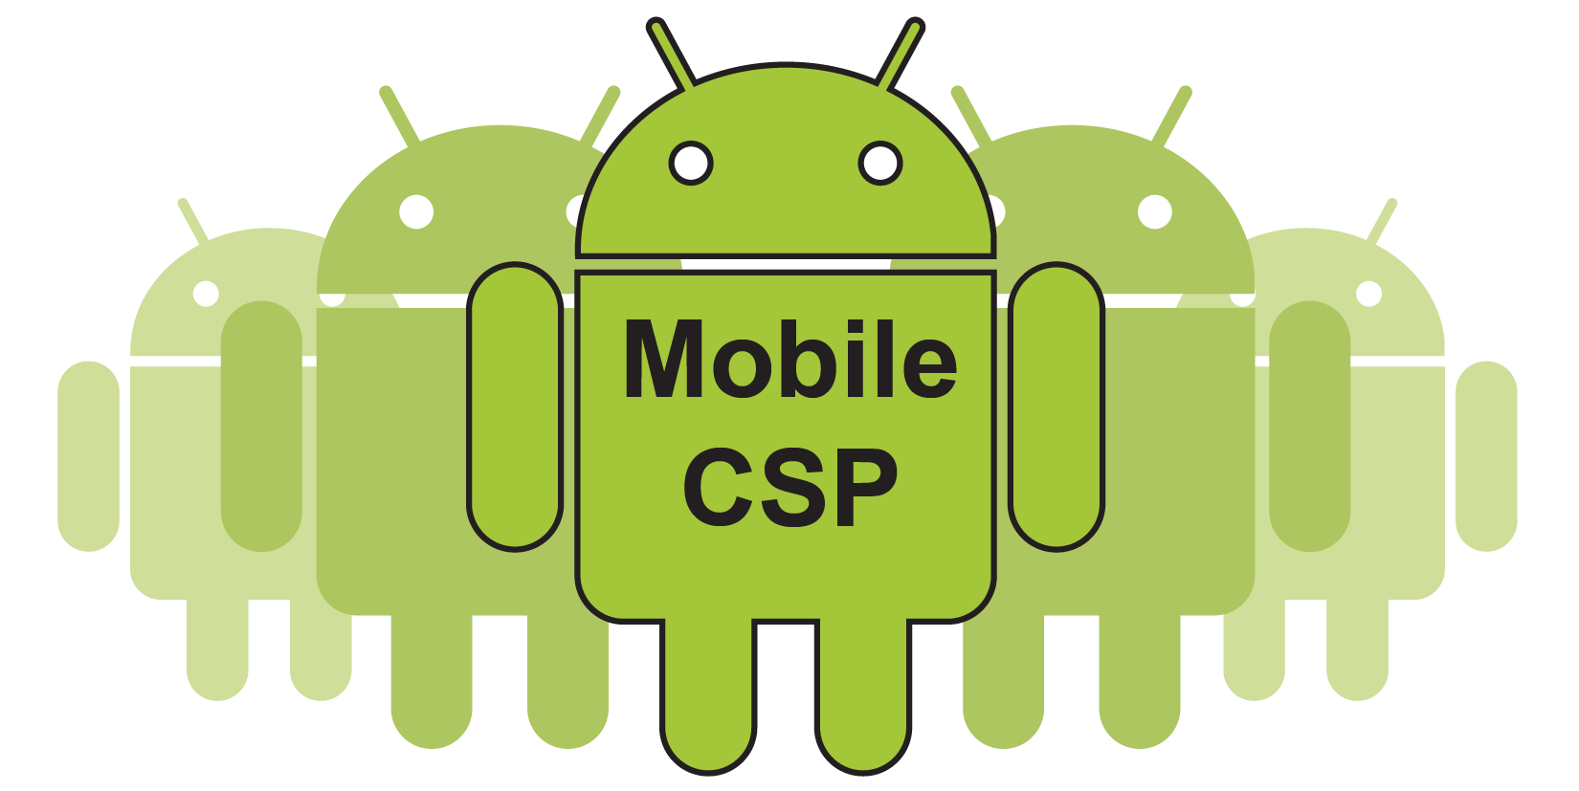

Mobile CSP

Troubleshooting Connection Problems

If your mobile device is having trouble connecting to App Inventor to run your apps, here are some things to try:

* Make sure that both the computer and the mobile device are on the same wifi network. Some locations have multiple wifi networks available and the device and the computer may connect to different networks by default.
* If the wifi networks require logging in, make sure both the computer and the mobile device are logged in. Try an Internet browser on both the computer and the mobile device to make sure they can both reach the Internet. Also, make sure that you have a strong wifi signal.
* Try the troubleshooting directions on <http://appinventor.mit.edu/explore/ai2/support/troubleshooting.html> summarized below:
  + Try to reach [http://rendezvous.appinventor.mit.edu](http://rendezvous.appinventor.mit.edu/) from your computer (from a browser).
  + Try to reach [http://rendezvous.appinventor.mit.edu](http://rendezvous.appinventor.mit.edu/) from the phone/tablet itself (using a browser).
  + If the steps above both work, try using the "ping" command to ping to the IP Address of the phone/tablet (displayed by the MIT AICompanion in its startup window) from your computer. If you are using Windows, type “cmd” to open the command prompt window from the Start menu and then type *ping IP address of the phone* in the cmd.exe window, if you are using Mac or Linux, type *ping IP address of the phone* in the terminal window. For detailed instruction see <http://www.wikihow.com/Ping-an-IP-Address>
  + If all of these steps succeed and Wireless App Inventor *still* doesn't work, then there may be a firewall between the computer and phone that is blocking ports 8001 and 9987. If you have a "telnet" program, you can attempt to telnet from the computer to the phone on these ports. If the connection won't complete, then there is likely a firewall in place that is blocking connections to the phone. Get your IT person involved at this point.
* Try connecting the device with the companion app in a different location, for example a different part of the school that gets better wifi reception, and at home to see if it works in a different setting. If so, it's a wifi/firewall issue in your classroom. You could also try starting a hotspot on your phone and connecting both computer and device to it to see if that works (bypassing your school wifi/firewall).
* If the device does not work in multiple locations, try doing a system update on the device (Settings/System/System Updates) and re-installing the companion app.
* Try **Build/App** in App Inventor instead of using the Companion app to see if that works better.
* Try using a **Connect/USB** wired connection instead (once again bypassing firewall/wifi issues). Here's directions on [how to set up USB debugging on the Zenpad.](https://docs.google.com/document/d/1ptUprMH2Jrh1HkmWkn4P_RMprsz0YPEROgff_TBflL4/edit?usp=sharing)
* Try using [Thunkable](http://thunkable.com/) (which is an offshoot of App Inventor) and their companion app which sometimes works better in poor wifi situations. You can export your .aia project and import into Thunkable and it will work fine. You will need to download the Thunkable companion app on the device.
* If your internet is unreliable, try setting up an offline copy of app inventor on each computer or on a local server. See [video](https://www.youtube.com/watch?v=KITcCSiFqC4) and [download](https://sourceforge.net/projects/ai2u/).